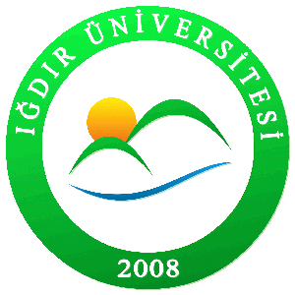


IGDIR UNIVERSITY
Acceptance Letter for Master/Doctorate Program

Date:…………
Address: Department of ……………….., Ş. Bulent Yurseven
Campus 76000 Suveren/Igdır

To Graduate Office

I inform you that Mr./Miss…………………….has been accepted as a candidate student to study in ………………………..department as master/doctorate program. He/she will be studying under the topic of ……………………………. Please contact me with any inquires about this student

Starting Term: …………………………….
Registration Date:……………………………….
Supervisor: ……………………………………….
Program: Master/Doctorate
Language and Graduate sufficiency: …………….

With my best regards,
Prof. ………………
Sign

Not: This is not a formal accepting letter from the university. This is one of the requirement for graduate programs applications.

